**PYTHON_INTERNSHIP_FULL_STACK_DEVELOPMENT_PROJECT – 2025**

* **PROJECT MEMBERS:**

**SIDDHESH / SHAMSUDDIN / PRATIBHA**

* PROJECT DETAILS:

1. HOME PAGE

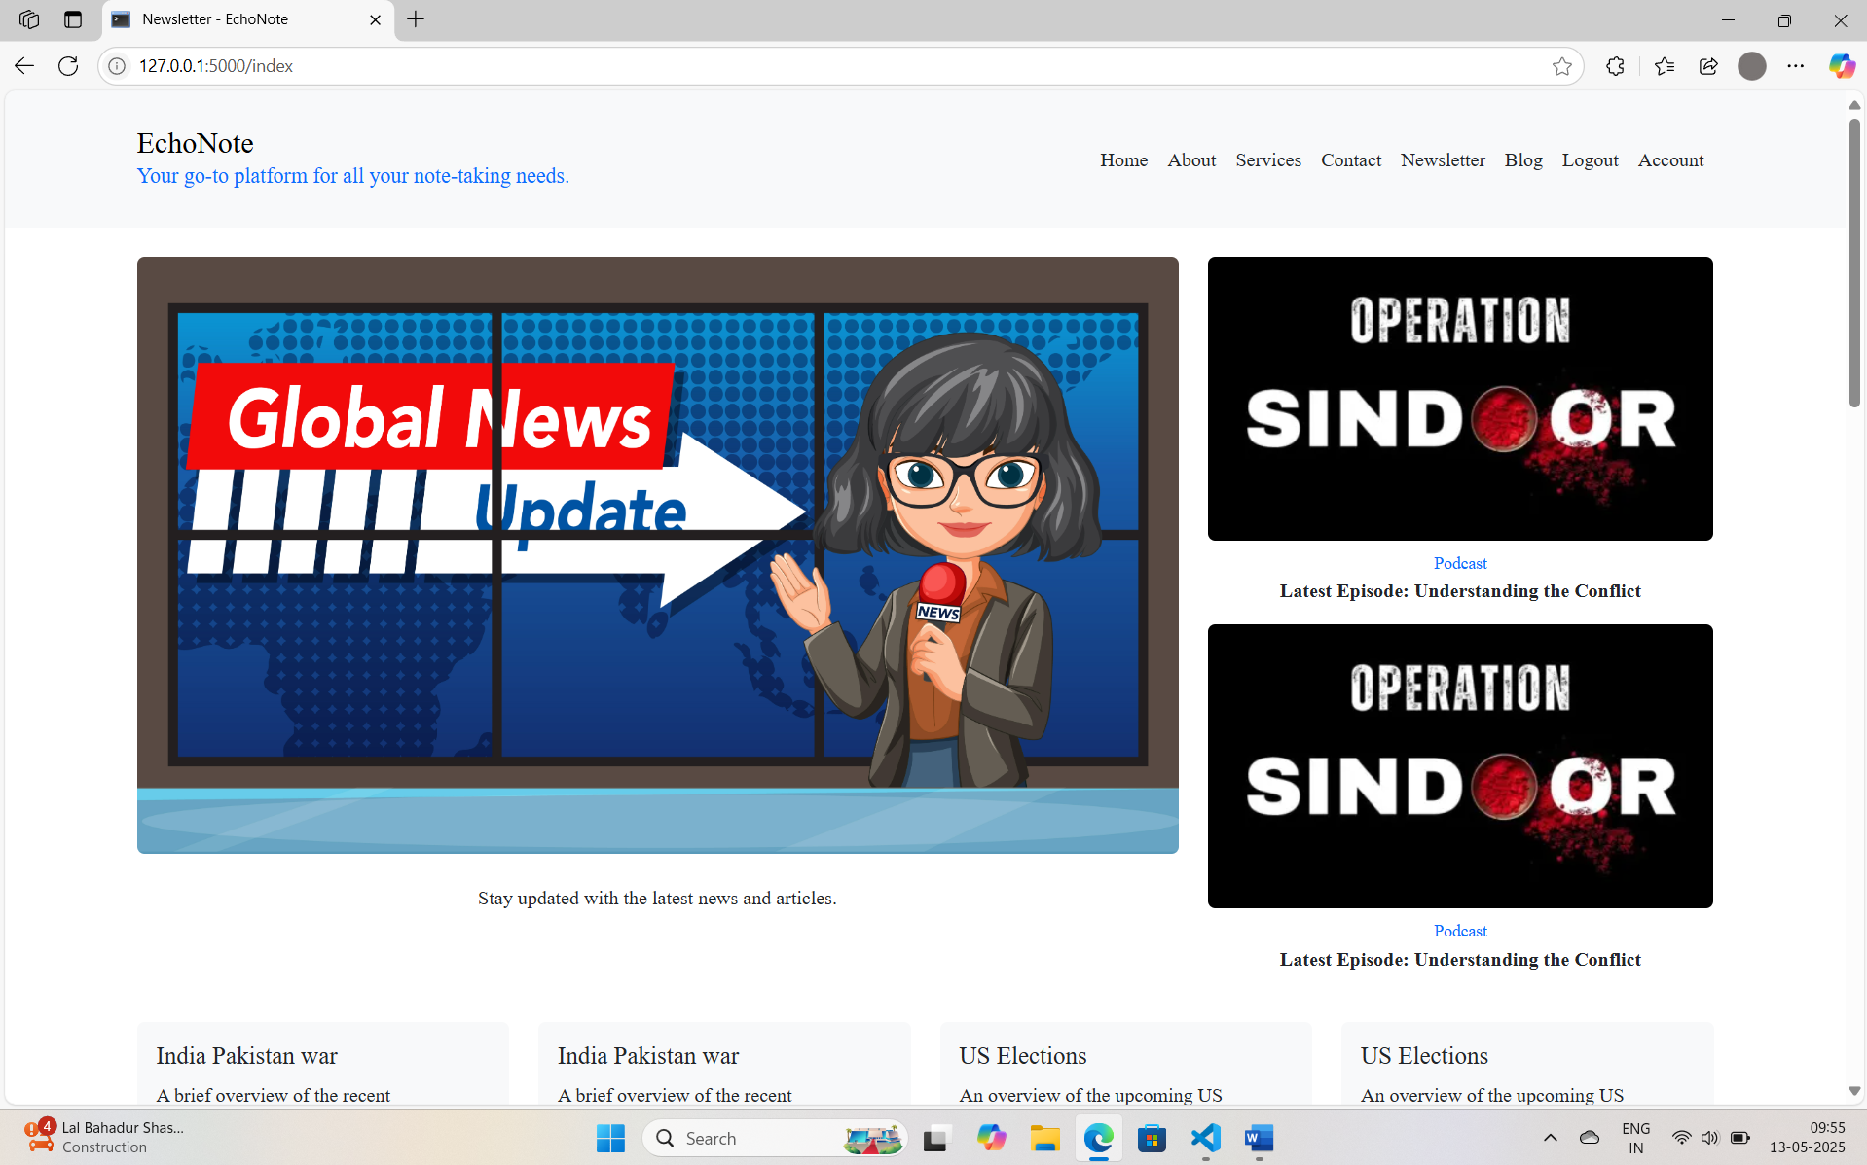

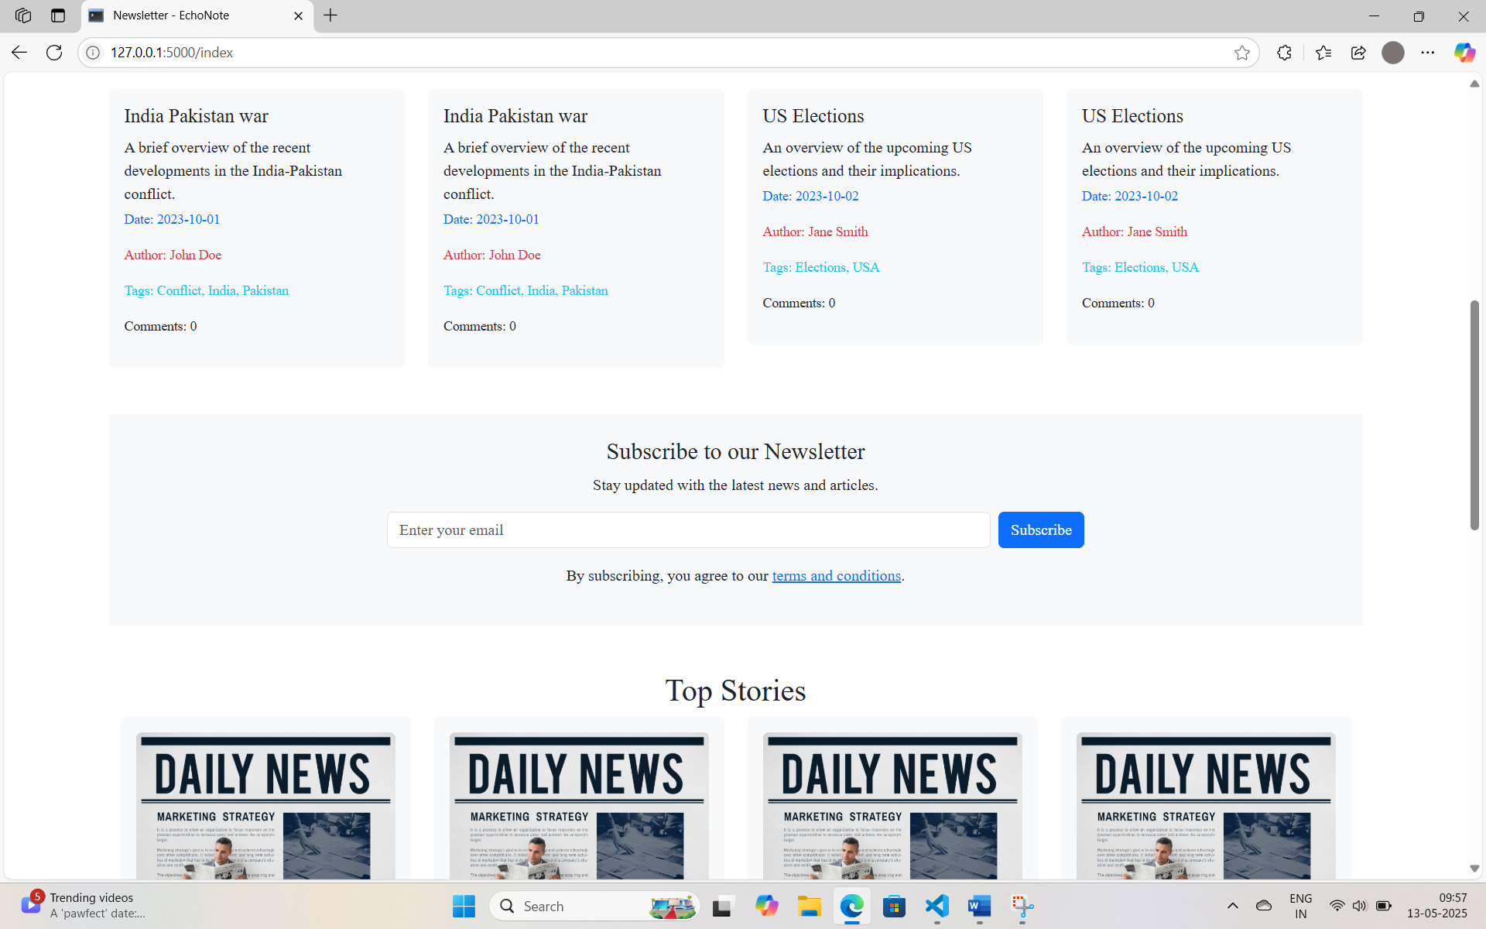

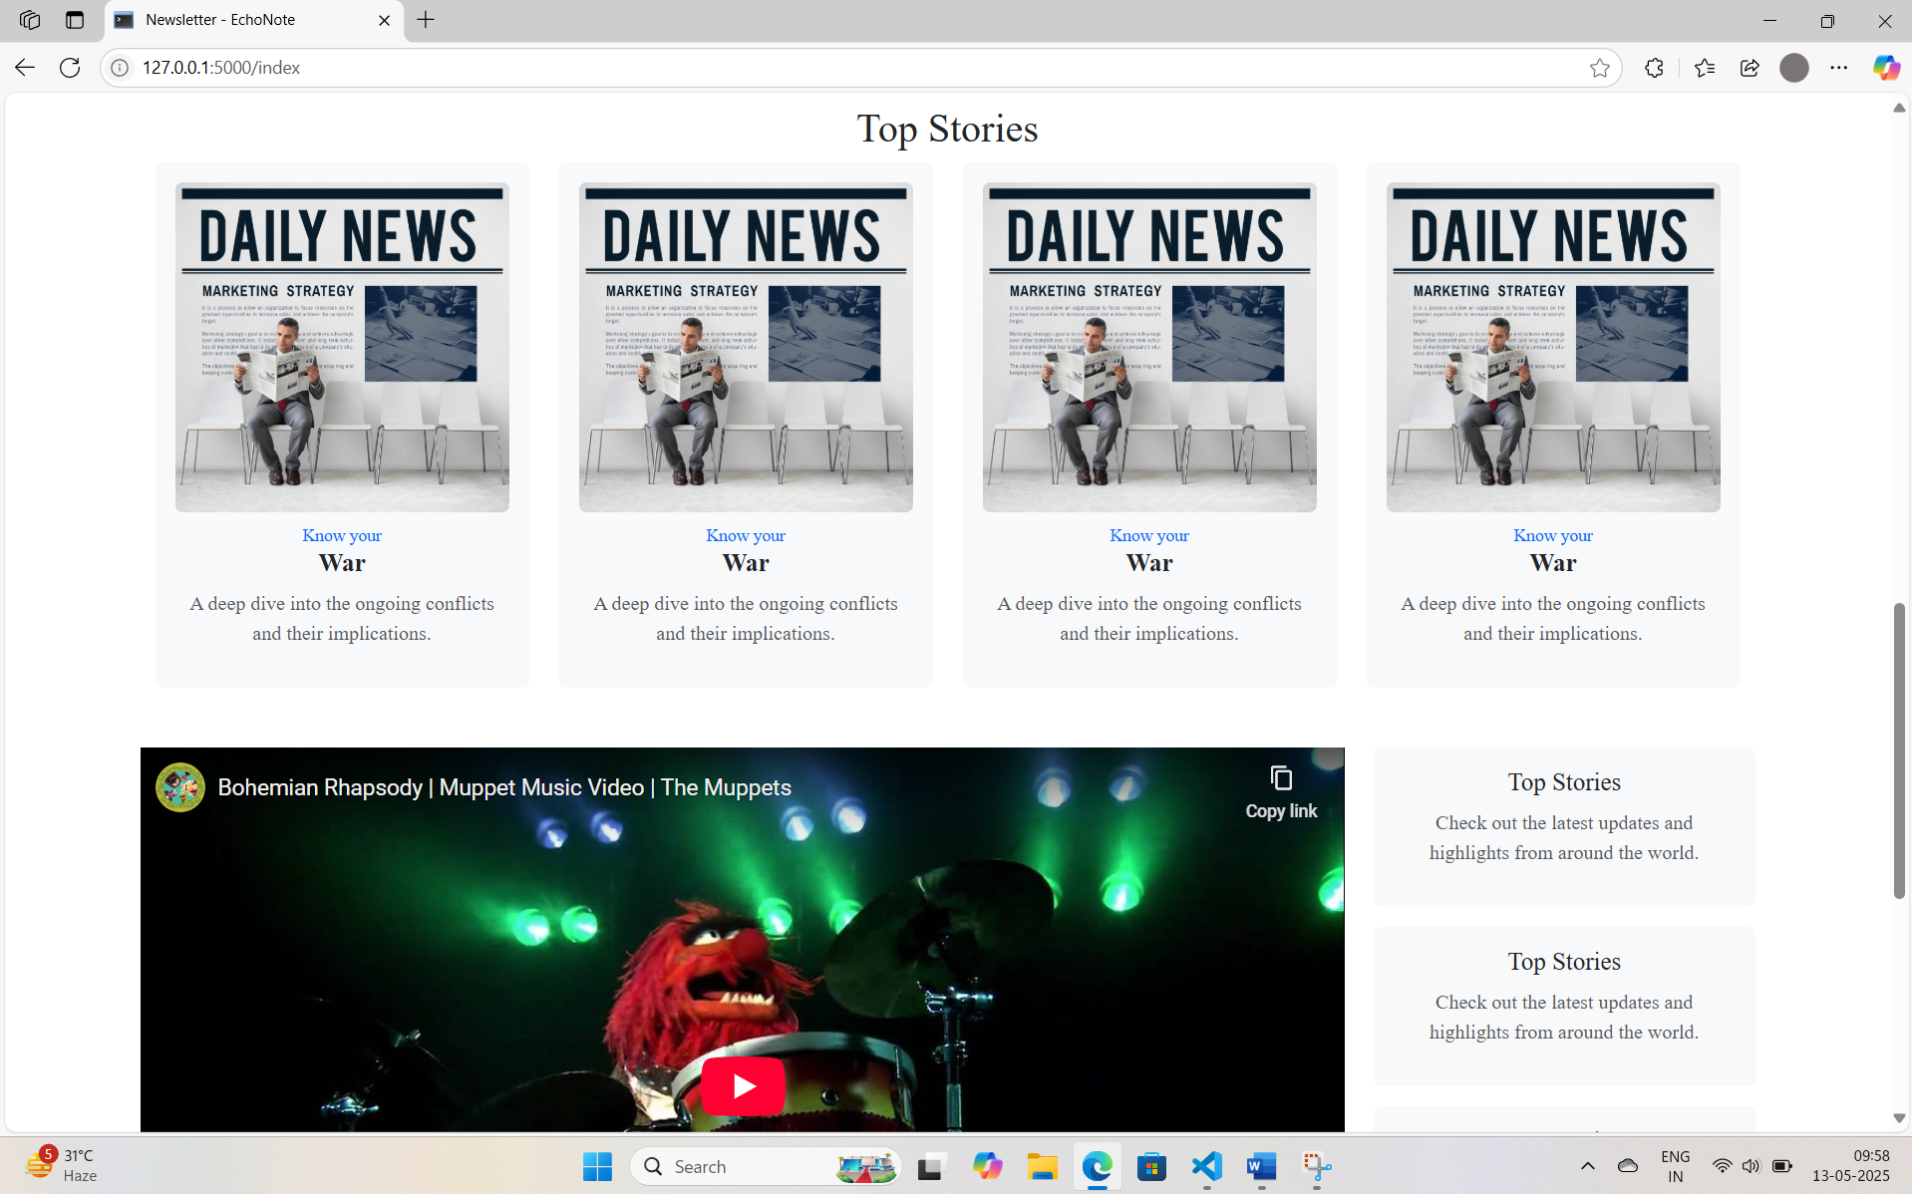

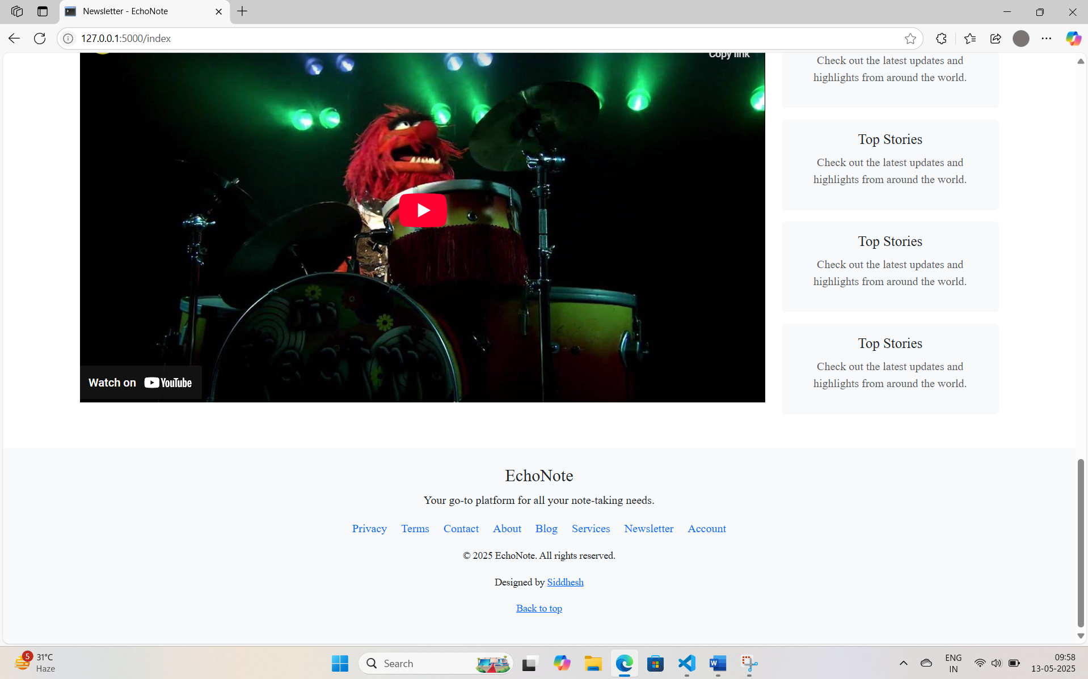

1. ABOUT PAGE:

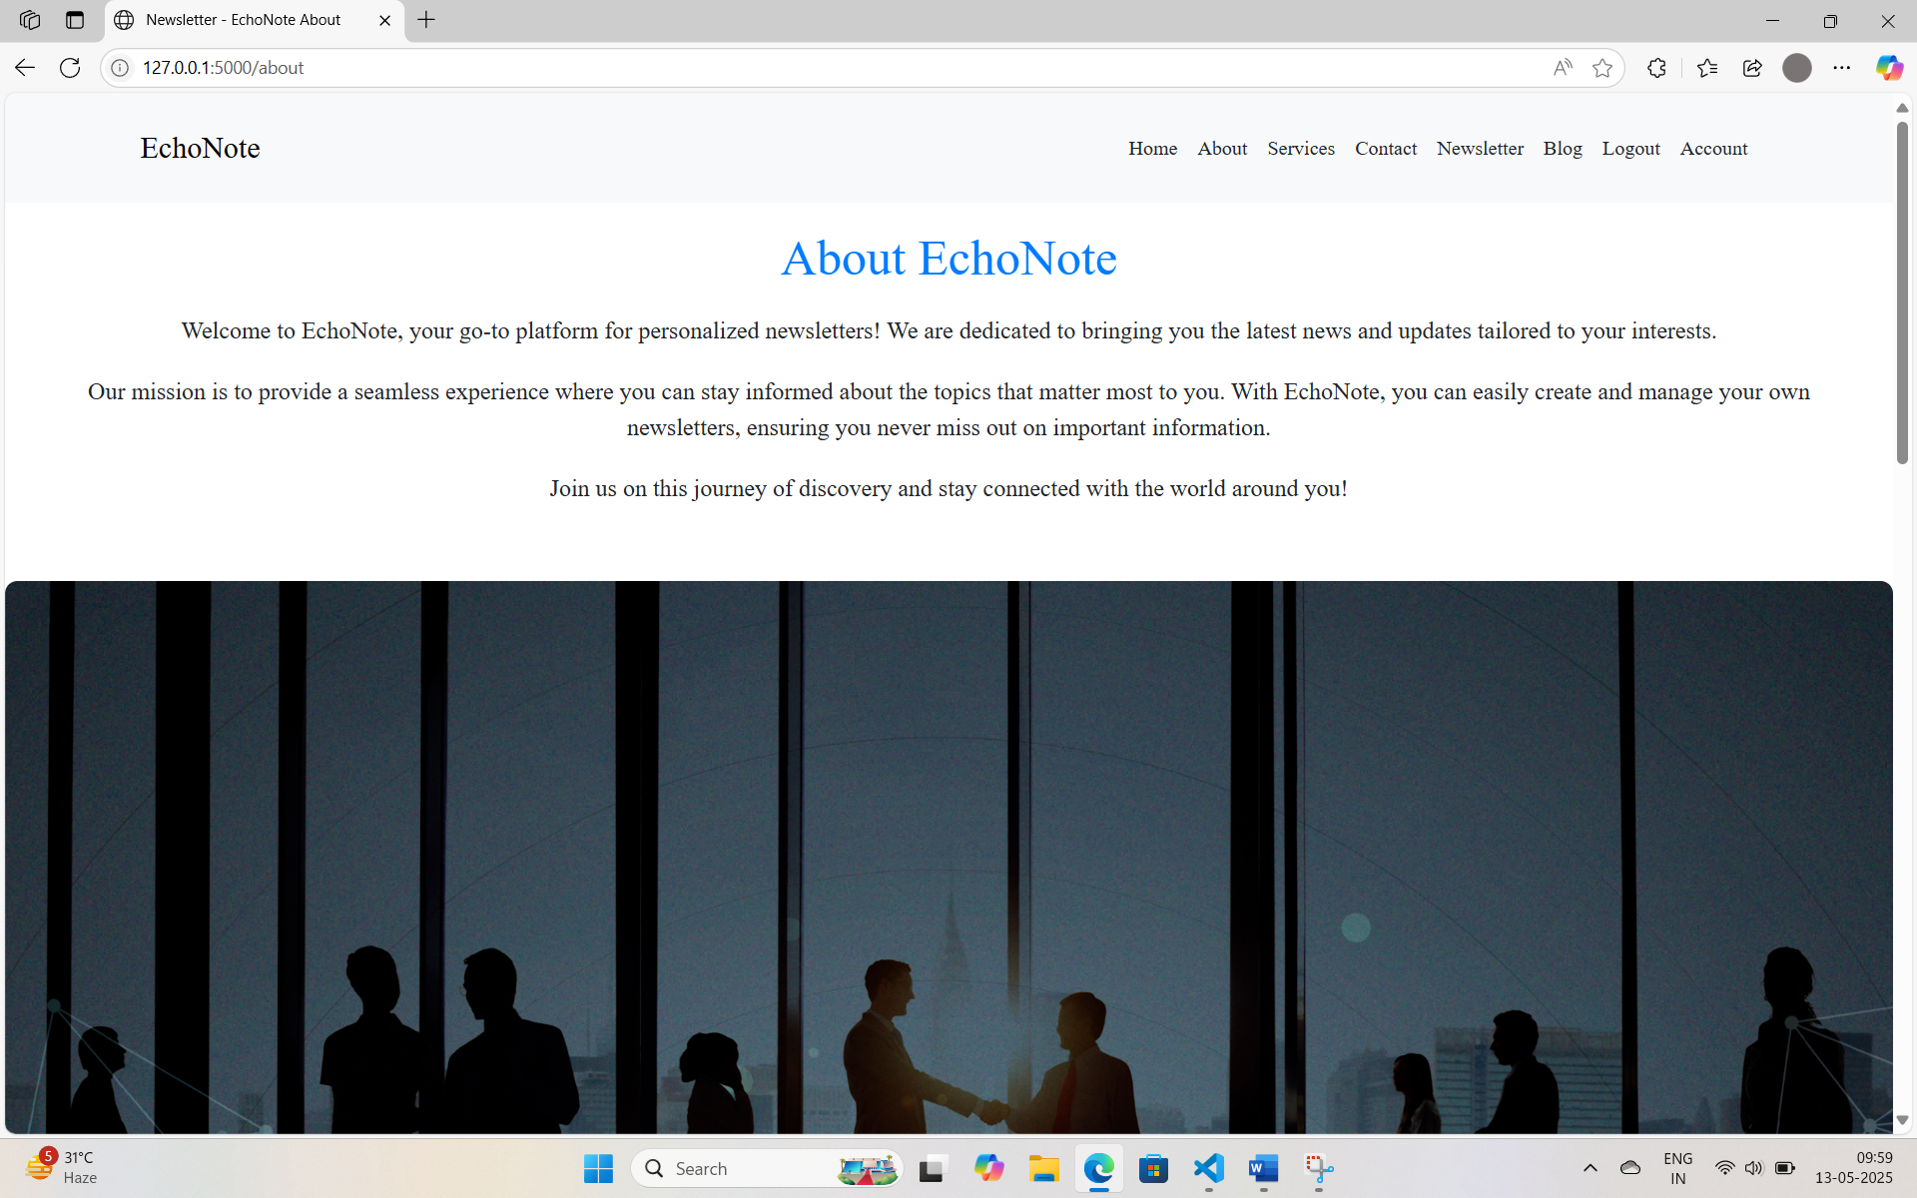

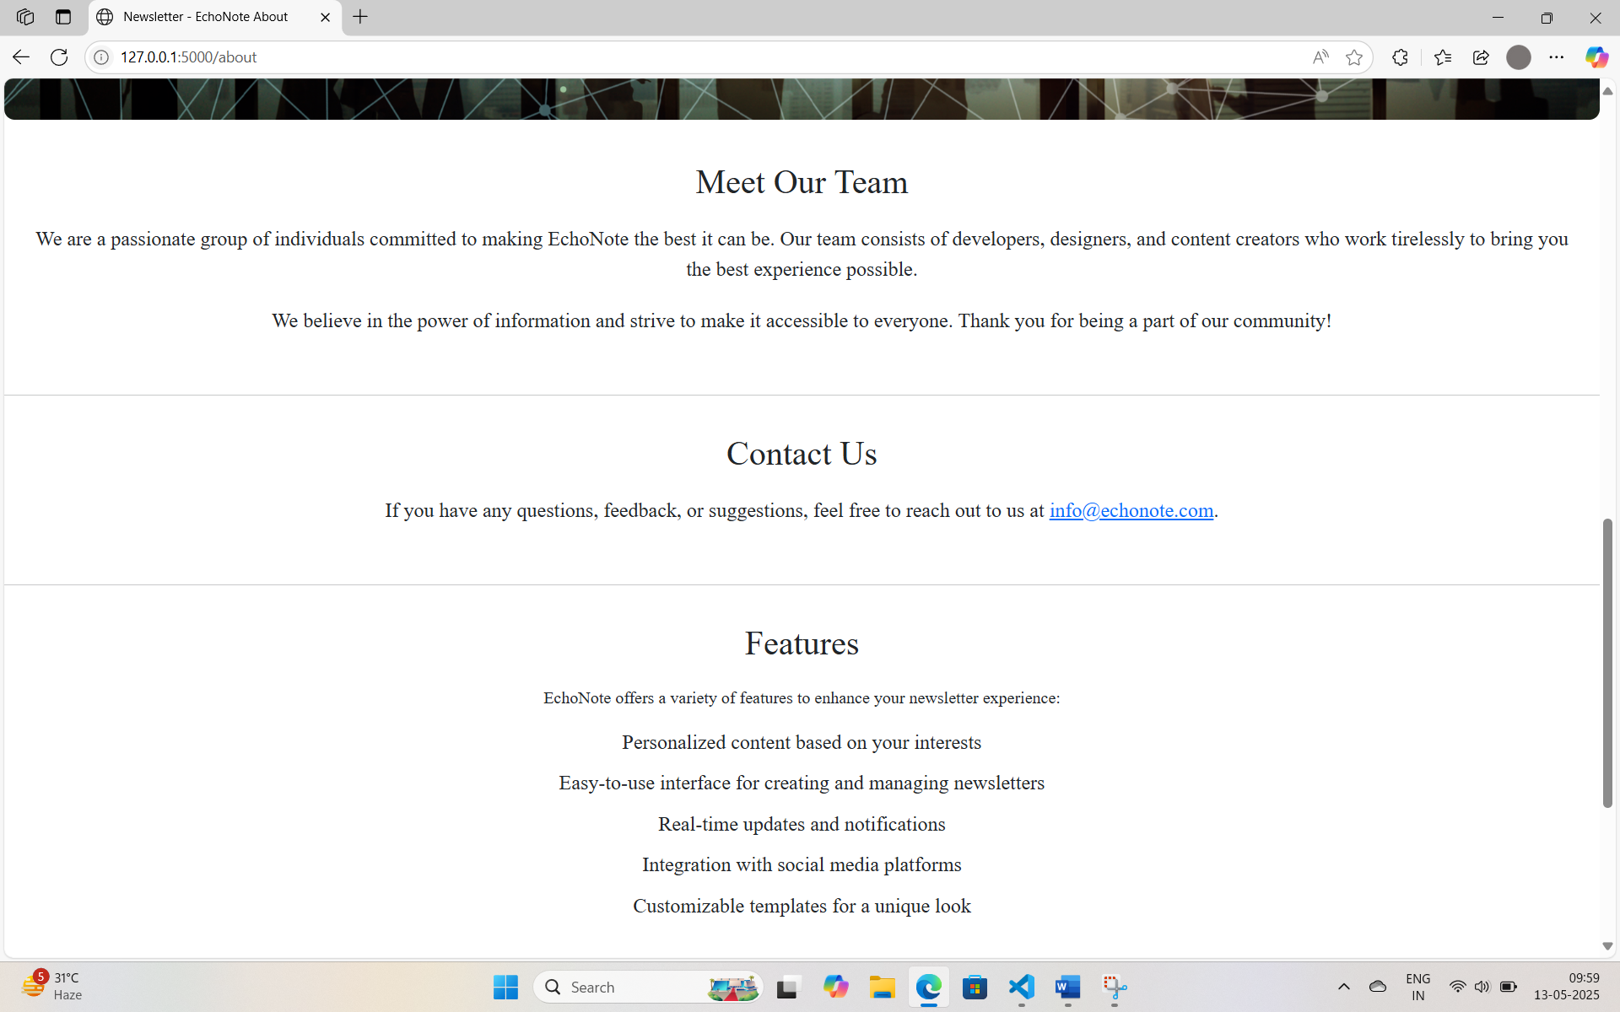

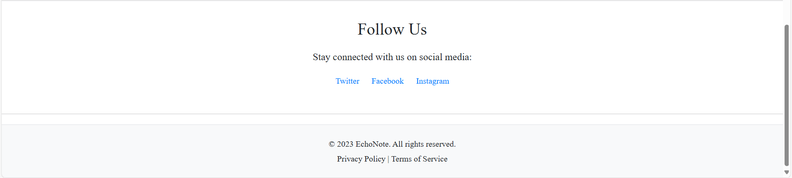

1. SERVICES PAGE:

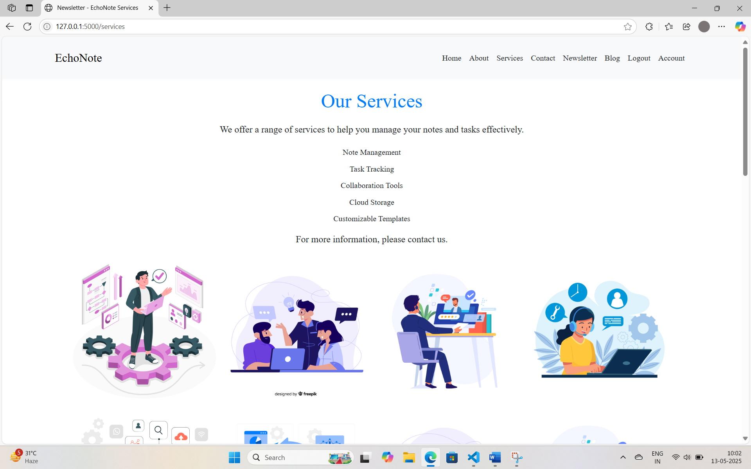

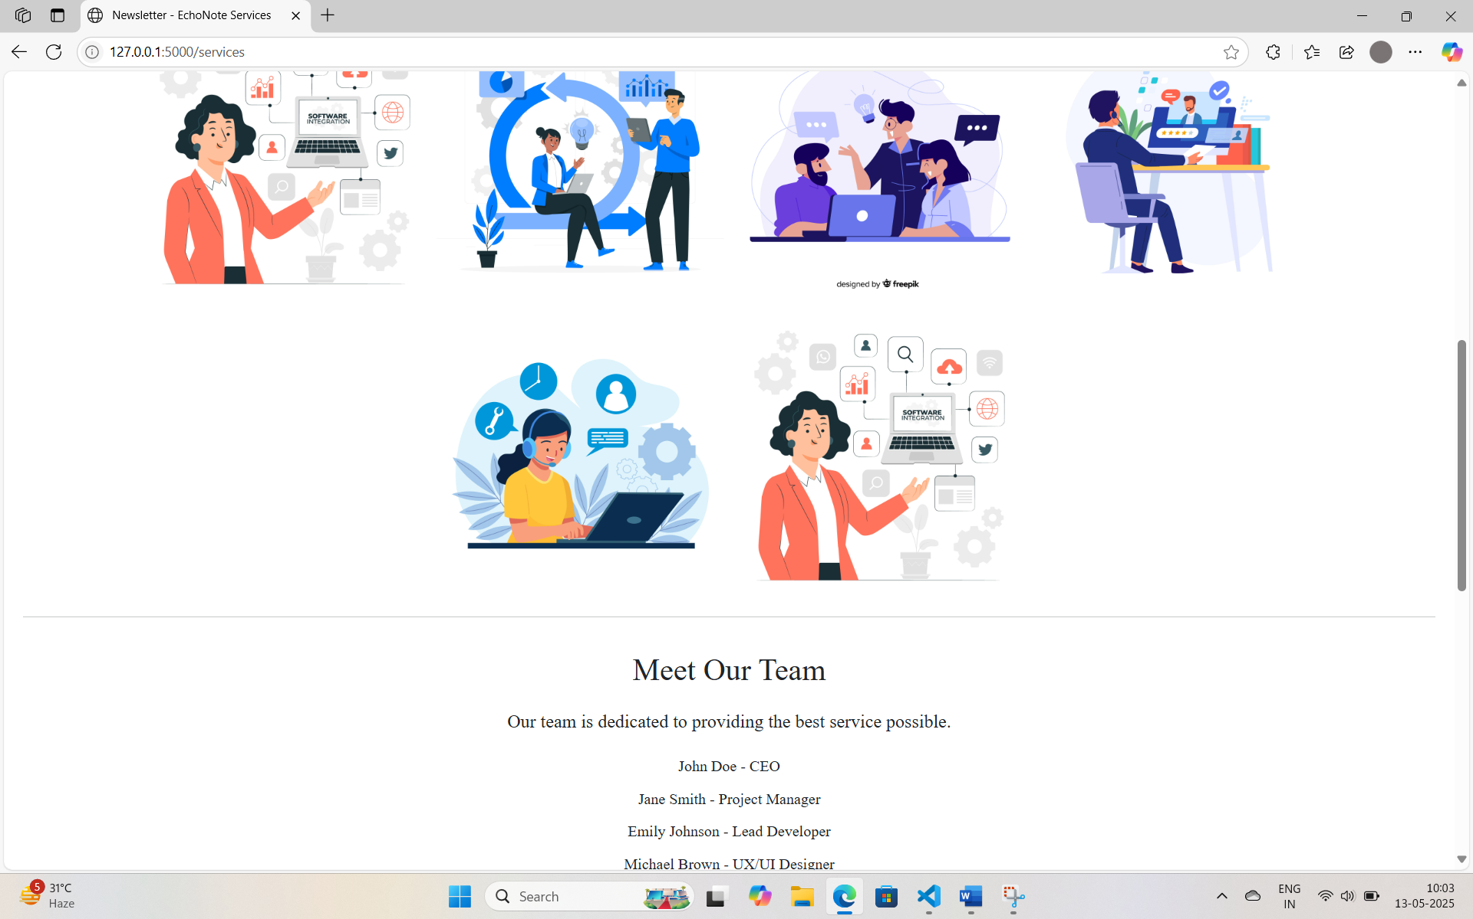

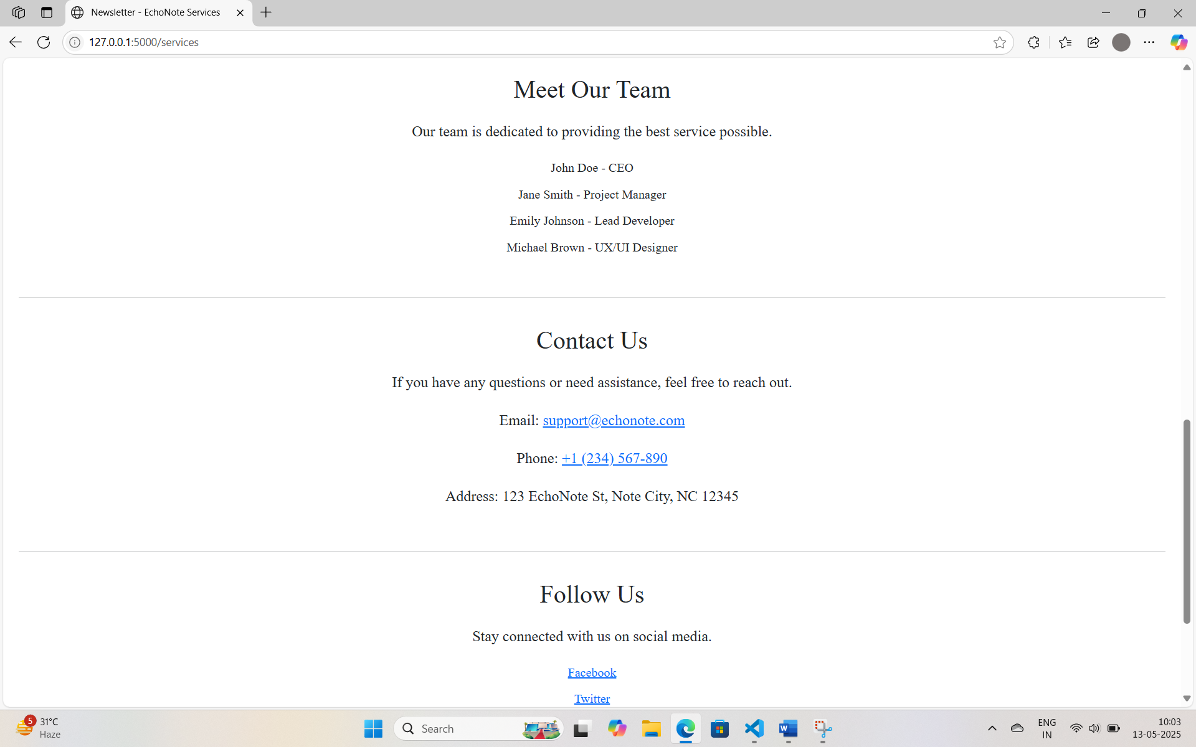



1. CONTACT PAGE:

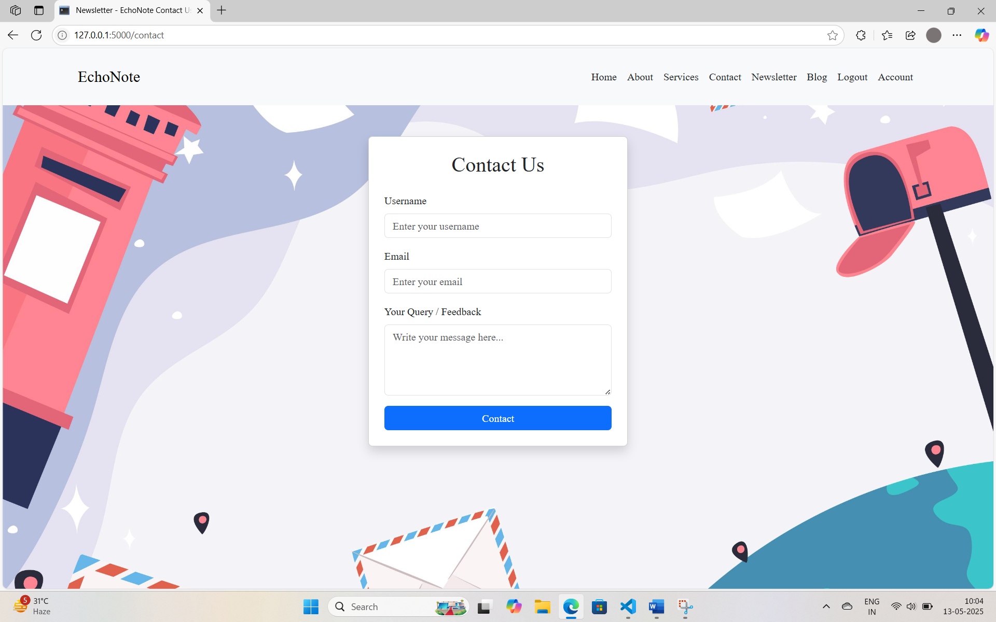

1. LOGIN / REGISTRATION PAGE:

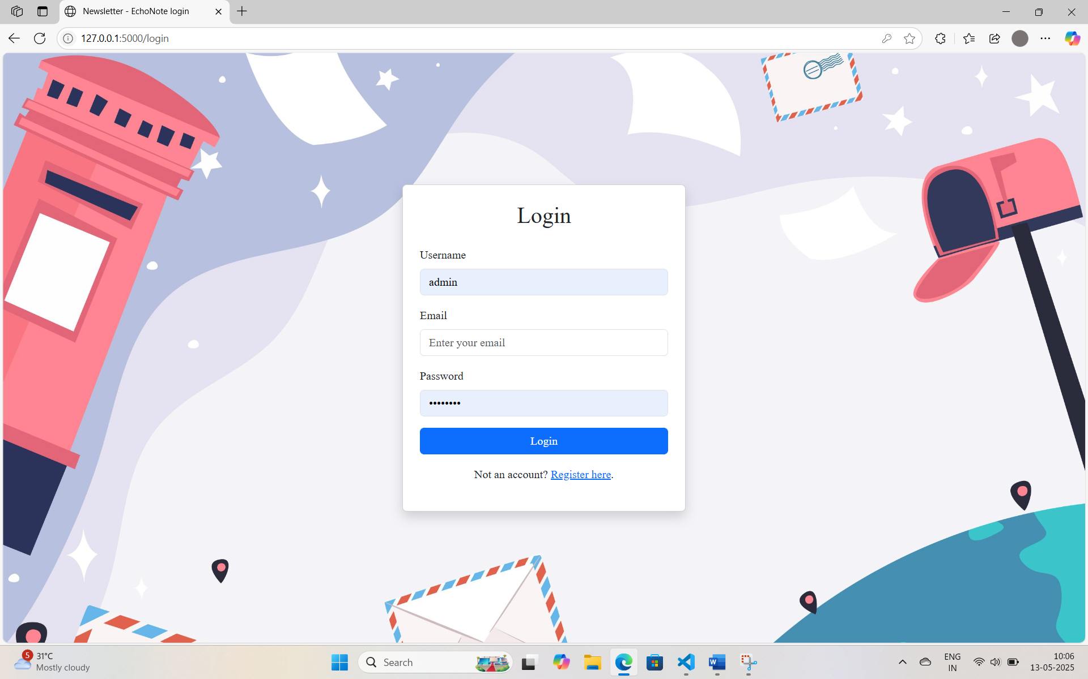

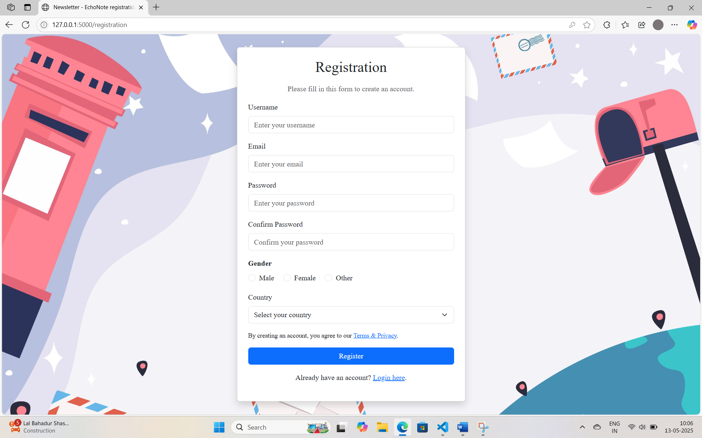

1. DASHBOARD PAGE:

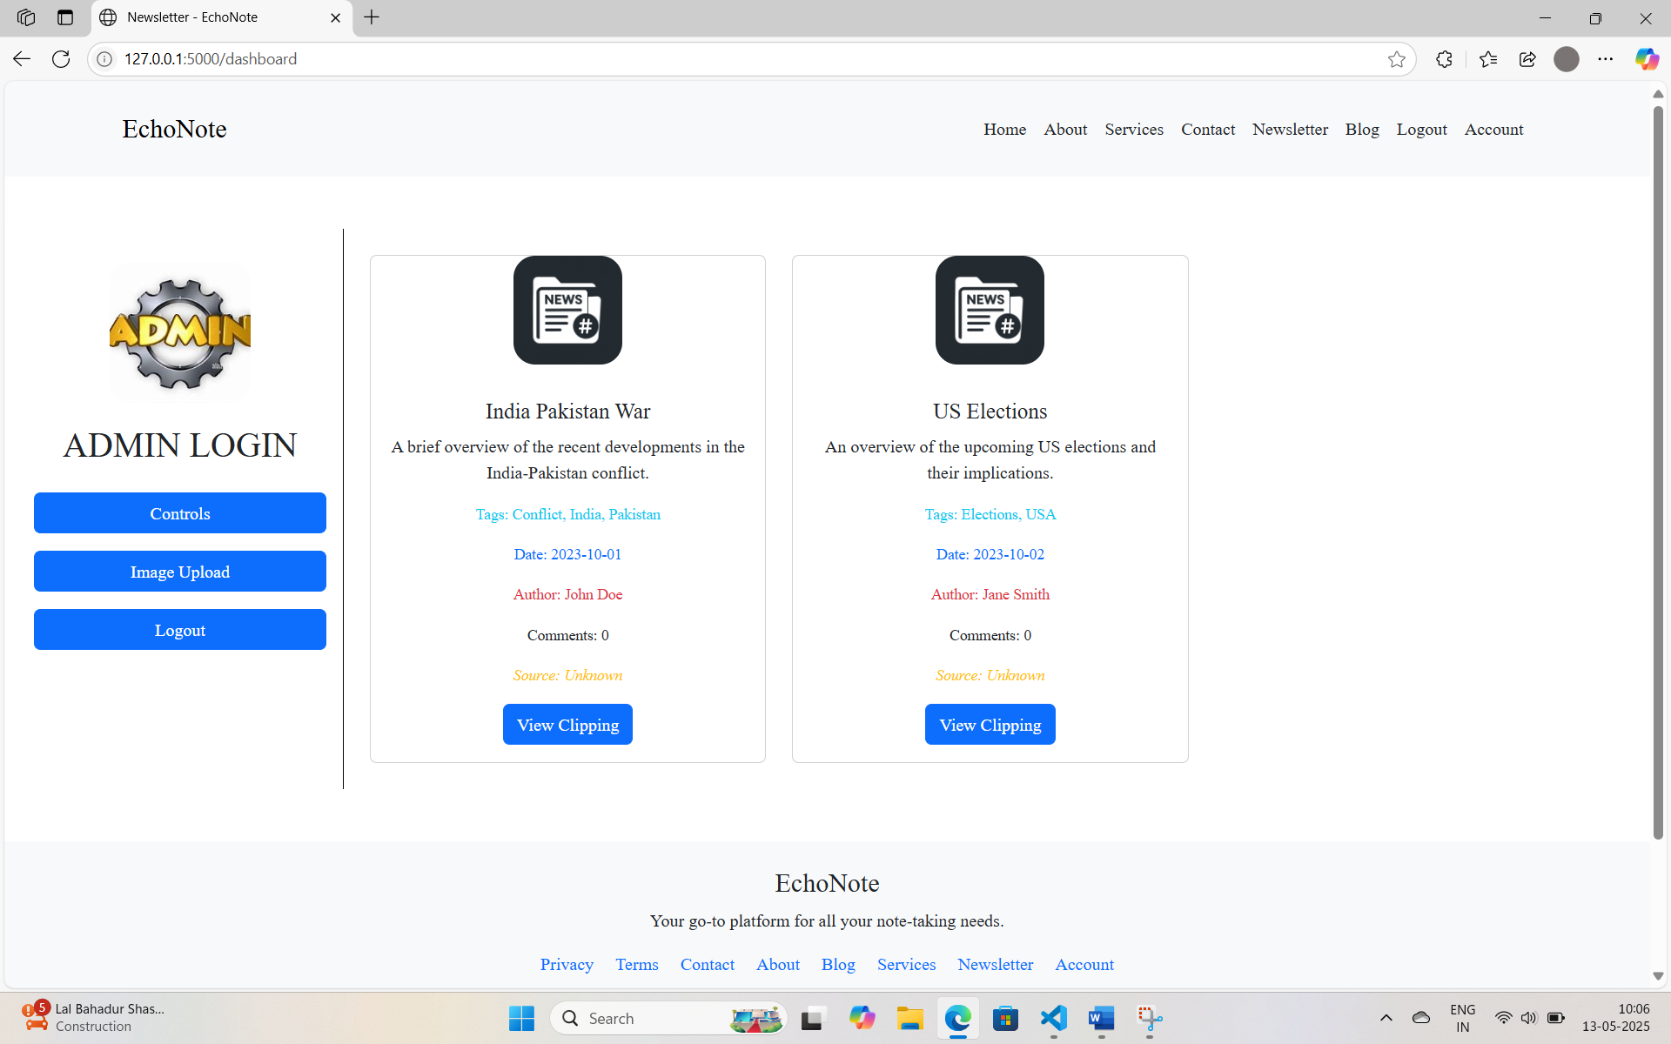

1. UPLOAD IMAGE PAGE:

